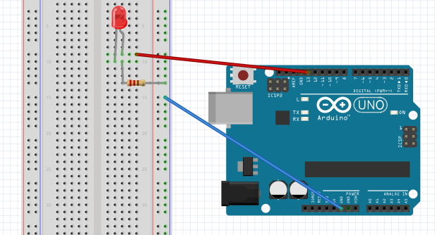

Figure - Blinking LED

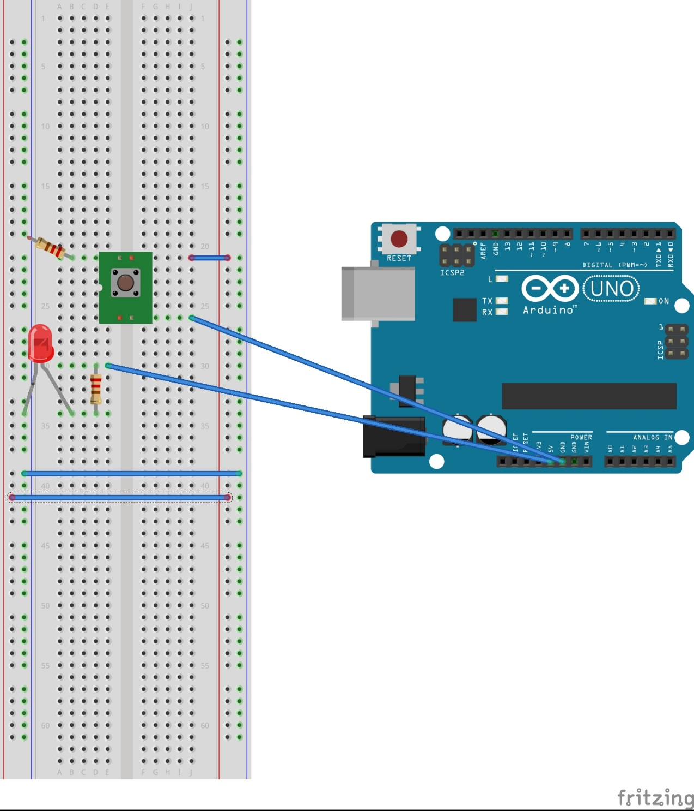

**Figure 2 - Blinking LED with switch**

/*

**Blink**

This program turns on an LED on for one second, then off for one second, repeatedly.

*/

// the setup function runs once when you press reset or power the board

void setup() {

// initialize digital pin 13 as an output.

pinMode(13, OUTPUT);

}

// the loop function runs over and over again forever

void loop() {

digitalWrite(13, HIGH); // turn the LED on (HIGH is the voltage level)

delay(1000); // wait for a second (1000ms)

digitalWrite(13, LOW); // turn the LED off by making the voltage LOW

delay(1000); // wait for a second

}

int button = 2; // this time we initialize pin 2 as the button

int led = 3; // and pin 3 as the LED

void setup() {

pinMode(button, INPUT); // the button is an input

pinMode(led, OUTPUT); // LED is an output

}

void loop() {

int buttonState = digitalRead(button); // this reads the value of the button

// if it’s pressed it will be 1 or HIGH

// if not it will be 0 or LOW

if (buttonState == 1) { // now the code checks if the button is pressed(1)

digitalWrite(led, 1); // if so the LED turns on

}

else { // otherwise

digitalWrite(led, 0); // the LED turns off

}

delay(1); // the program then waits 1 second before checking the // button again

}

